**1. Dataset Overview:**

**- Size of Dataset:**

Total entries: 2616

Total variables: 39

**- Features:**

['Page Name', 'User Name', 'Facebook Id', 'Page Category', 'Page Admin Top Country', 'Page Description', 'Page Created', 'Followers at Posting', 'Post Created', 'Post Created Date', 'Post Created Time', 'Type', 'Total Interactions', 'Likes', 'Comments', 'Shares', 'Love', 'Wow', 'Haha', 'Sad', 'Angry', 'Care', 'Video Share Status', 'Is Video Owner?', 'Post Views', 'Total Views', 'Total Views For All Crossposts', 'Video Length', 'URL', 'Message', 'Link', 'Final Link', 'Image Text', 'Link Text', 'Description', 'Sponsor Id', 'Sponsor Name', 'Sponsor Category', 'Overperforming Score (weighted \x97 Likes 1x Shares 1x Comments 1x Love 1x Wow 1x Haha 1x Sad 1x Angry 1x Care 1x )']

**- Missing Values:**

Page Name 0

User Name 15

Facebook Id 0

Page Category 0

Page Admin Top Country 162

Page Description 0

Page Created 0

Followers at Posting 0

Post Created 0

Post Created Date 0

Post Created Time 0

Type 0

Total Interactions 0

Likes 0

Comments 0

Shares 0

Love 0

Wow 0

Haha 0

Sad 0

Angry 0

Care 0

Video Share Status 2006

Is Video Owner? 0

Post Views 0

Total Views 0

Total Views For All Crossposts 0

Video Length 2006

URL 0

Message 58

Link 19

Final Link 2301

Image Text 1900

Link Text 372

Description 2030

Sponsor Id 2613

Sponsor Name 2613

Sponsor Category 2613

Overperforming Score (weighted  Likes 1x Shares 1x

Comments 1x Love 1x Wow 1x Haha 1x Sad 1x Angry 1x Care 1x ) 0

dtype: int64

**- Percentage of Missing Values:**

Page Name 0.000000

User Name 0.573394

Facebook Id 0.000000

Page Category 0.000000

Page Admin Top Country 6.192661

Page Description 0.000000

Page Created 0.000000

Followers at Posting 0.000000

Post Created 0.000000

Post Created Date 0.000000

Post Created Time 0.000000

Type 0.000000

Total Interactions 0.000000

Likes 0.000000

Comments 0.000000

Shares 0.000000

Love 0.000000

Wow 0.000000

Haha 0.000000

Sad 0.000000

Angry 0.000000

Care 0.000000

Video Share Status 76.681957

Is Video Owner? 0.000000

Post Views 0.000000

Total Views 0.000000

Total Views For All Crossposts 0.000000

Video Length 76.681957

URL 0.000000

Message 2.217125

Link 0.726300

Final Link 87.958716

Image Text 72.629969

Link Text 14.220183

Description 77.599388

Sponsor Id 99.885321

Sponsor Name 99.885321

Sponsor Category 99.885321

Overperforming Score (weighted  Likes 1x Shares 1x

Comments 1x Love 1x Wow 1x Haha 1x Sad 1x Angry 1x Care 1x ) 0.000000

dtype: float64

**2. Data Processing:**

**- Cleaning Steps:**

* Duplicates Removed.
* Missing Values Handled.

Page Name ... Link Text

0 Disney ... Photos from Disney's post

1 Willis Towers Watson ... Timeline Photos

2 ServiceNow ... Palo Alto Networks rockets resiliency by trans...

3 Cognizant ... Future of work: Indian businesses thrive on di...

4 Zebra Technologies ... The Game-Changing Technology Of RFID - IAA - I...

[5 rows x 10 columns]

**Selected Features:**

['Page Name', 'Followers at Posting', 'Post Created Date', 'Type', 'Total Interactions', 'Likes', 'Comments', 'Shares', 'Message', 'Link Text']

**New Features:**

- Feature Engineering:

- New Features Calculated:

* Engagement Ratio
* Post Hour
* Post Day
* Post Month
* Post Length
* Presence of Media

Page Name ... Presence of Media

131 Alexion Pharmaceuticals ... 0

590 Alexion Pharmaceuticals ... 0

754 Dover Corporation ... 1

838 SL Green Realty Corp. ... 1

924 HollyFrontier Careers ... 1

[5 rows x 16 columns]

**3. Analytical Methodology:**

- Analysis Tools: This analysis was performed using Python with libraries such as Pandas, NumPy, Matplotlib, and Seaborn.

- Model Selection: Linear regression and other statistical models can be considered for evaluating the data, depending on the specific analysis goals and assumptions.

- Visualizations: Visualizations were created using Matplotlib and Seaborn to illustrate data processing stages and preliminary findings.

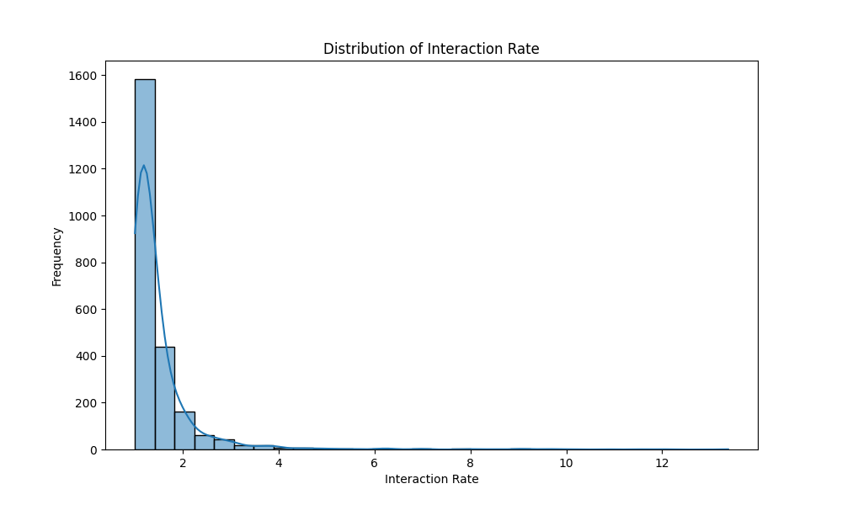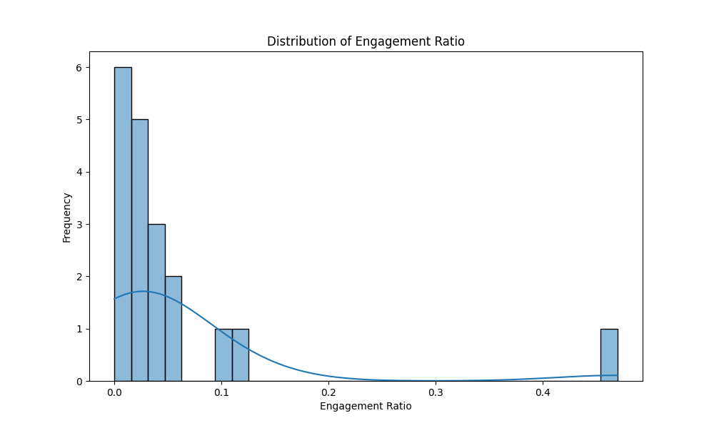

**4. Analysis Report**

**Key Insights:**

- Identification of post types, topics, or content that tend to receive higher interaction rates:

Type

Link 0.126830

Photo 0.041536

Native Video 0.023429

Name: Interaction Rate, dtype: float64

**Recommendations:**

Strategic advice for the marketing team based on analysis results.

Suggestions for crafting engaging Facebook posts:

- Analyze the correlation between different post types (e.g., link, photo, video) and their respective interaction rates. Allocate more resources to post types that have shown higher interaction rates.

- Experiment with different content formats (e.g., images, videos, text posts) to see which ones resonate best with the audience. Use A/B testing to compare engagement metrics across different content formats.

- Encourage user-generated content by running contests, polls, or user submissions. This often leads to higher engagement as it fosters community participation and ownership.

- Leverage trending topics, events, or holidays to create timely and relevant content. Monitor social media trends and adapt your content strategy accordingly to capitalize on current interests.

- Invest in paid advertising to promote high-performing posts and reach a broader audience. Use targeting options to ensure that ads are shown to users who are most likely to engage with the content.

- Continuously monitor and analyze key performance metrics to track the effectiveness of your content strategy. Regularly iterate and optimize your approach based on data-driven insights.